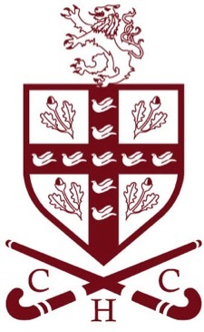
Crawley Hockey Club

New Pitch Proposal

Dear Members,

The Club is raising funds towards the cost of a new playing surface, in partnership with Hazelwick School.
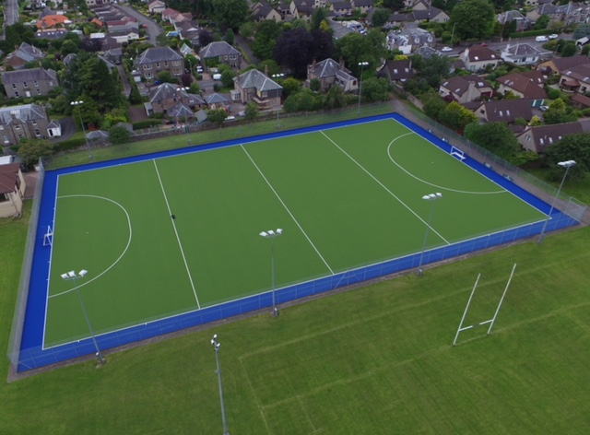

Total cost £185 000.

The aim is to promote hockey and physical activities across all ages.
This innovative partnership will guarantee our security of pitch tenure for the next 20 years under a Joint Use Agreement.

The new surface is a replacement for the current playing surface with a sand-dressed pitch (England Hockey Category 1) suitable for multi-sport use and available to the community throughout the year. The high quality surface will provide opportunity for new activities, disabled access and encourage use by a wide range of ages (5 to 75+).
There is no hockey pitch of this standard in Crawley where pitches are football dominated. England Hockey states that a sand-dressed pitch is required for the development of hockey and participation at Regional level.

(For local pitches of this standard think Reigate Grammer School, Ardingly and Hurstpierpoint Colleges ).

Hockey is a popular and well-established sport both across Sussex and nationally and one that has seen the number of people playing club hockey increase by 40% since 2011. The increase for players under 16 is 80% and is set to double for girls by the end of 2018 (England Hockey). It is a top five school sport nationally, yet while it proves increasingly popular in local Primary Schools there is no provision in Crawley Secondary Schools for development and match play.

Crawley has the largest population in West Sussex. There is huge potential to increase participation in sport with the benefits in health, social cohesion and well-being. A high quality facility is essential for building attractive and sustainable sport in Crawley.

CHC needs a high quality pitch and a secure home venue . Next year sees our 70th Anniversary as a Club and 2018 presents a unique opportunity to achieve this project.

Whether you have been part of CHC for weeks, years or decades

Your Club needs you!

Please

Talk to, phone, text or alternatively email Keith or Sym on

Email: crawleyhockeypitchpartners @hotmail.com

With offers of help, sources of funding, contacts with companies……..

Together this Club can!

Keith Truter Sym Savage

CHC Chair CHC President

